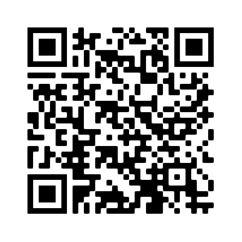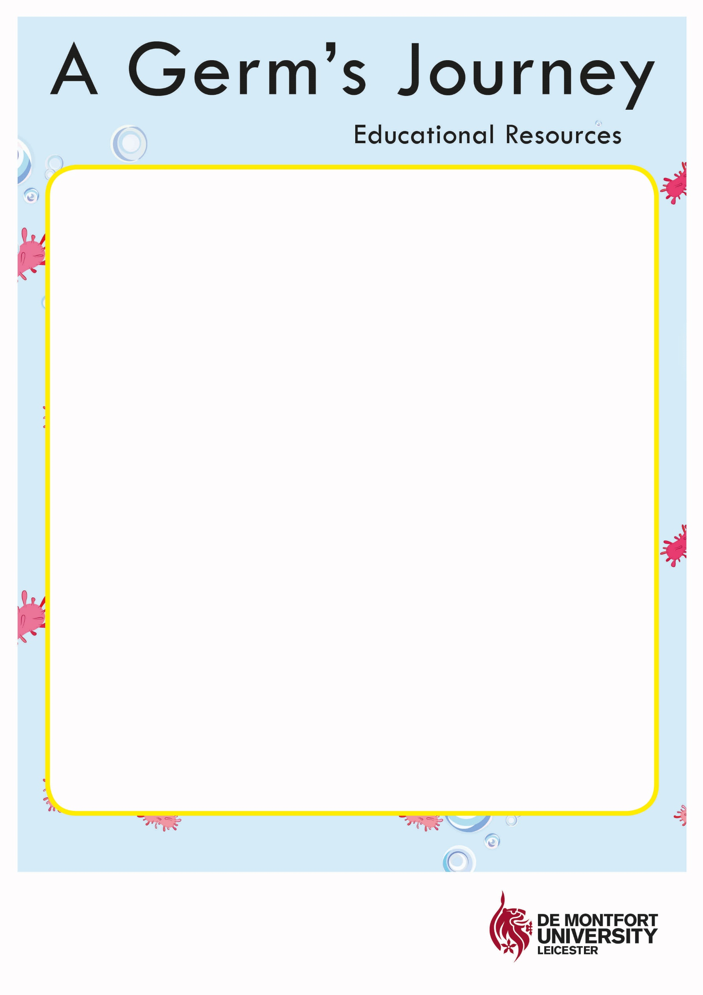

**Handwashing Song**

*Scrub, scrub, scrub in between your fingers   
Scrub, scrub, scrub under your nails   
Rubadub rub your hands together   
Rubadub rub round your wrists*

*Number One: Get your clean water   
Number Two: Get your hands wet   
Number three: Wash them with soap   
Can you see the bubbles yet?*

*Scrub, scrub, scrub in between your fingers   
Scrub, scrub, scrub under your nails   
Rubadub rub your hands together   
Rubadub rub round your wrists*

*Number Four: Wash off the bubbles   
Number Five: Is the water clean?   
Number Six: Now dry your hands   
Remember germs can’t be seen*

*Bubble, bubble, bubble. Bubble, bubble, bubble. Bubble, bubble, bubble. I’m washing my hands!  
Bubble, bubble, bubble. Bubble, bubble, bubble. Bubble, bubble, bubble. I’m washing my hands!*

*Scrub, scrub, scrub in between your fingers   
Scrub, scrub, scrub under your nails   
Rubadub rub your hands together   
Rubadub rub round your wrists*

*BYE BYE GERMS!*